Obfuscation of LLC files

This document describes the usage of the de-id.sh bash script for the purpose of obscuring client held llc files

Document Status: Draft

Prepared by:Tom Butler

Released by:

Date: 24/05/2019

Reference Number:

Document name:

Version: 0.1

**Background**

A TrustVault connector has been deployed on your premises and has been creating processed LLC files from the meta-data collection provided by your Office365 subscription or Exchange instance. At the end of the term (usually 90 days) you will have significant volume of processed data.

You have an internal requirement that ensures all internal staff in your organization is not recognizable when viewed on a user interface or report.

**Description**

The de-id.sh script will search through all the files in the staging location and create a sorted and unique list of all internal staff. Next an obscurity table will be constructed using the Caesar Cipher

**Original Name** **Ciphered Name**

abubakar.abbas xyryxhxo.xyyxp

abubakar.latif xyryxhxo.ixqfc

abubakar.ogashuwa xyryxhxo.ldxpertx

abubakari.sadique xyryxhxof.pxafnrb

…………………. …………………..

The script continues and carries out a ‘search and replace’ on all llc files recursively where the original name will be replaced with a ciphered version.

**Usage**

The Scheduled task that operates the connector script must be stopped as the assigned term for collection is now complete.

The llc files have been created in a ‘stage’ directory on your Linux server.

Backup the stage directory

# cp -R stage stagebkp

cd to the stage dir and get the path

# pwd

Example from ‘pwd’

/usr/src/anon/stage

Only llc files must exist in the stage directory. Remove everything else

**Install the script**

cd /usr/src

mkdir anon

sftp the de-id.tar.gz to the anon directory

**Untar the script**

tar zxvf de-id.tar.gz

chmod a+x de-id.sh

chmod -R 777 stage

**Edit the script**

#vi de-id.sh

Edit lines 5 and 6 to suite your environment

DOMAIN=<your domain> preceded with ‘@’

STAGE=<from pwd> ended with ‘/’

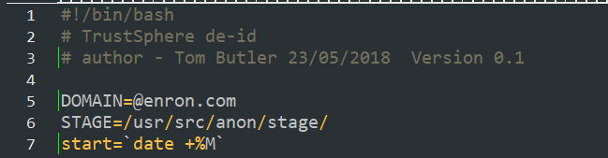

Save and exit vi

**Usage**

On your terminal in the anon directory

#./de-id.sh

Throughout the process, messages will be written to the screen.

[root@v3test anon]# ./de-id.sh

Building a list of llc files

reading enron-1234.llc file and preparing names

reading enron-5678.llc file and preparing names

reading enron-9012.llc file and preparing names

sorting 16382 names

creating anonymization table

Processing 1 of 3 llc files

Processing 2 of 3 llc files

Processing 3 of 3 llc files

Time taken -46 minutes

The anonymization keyfile.txt has been created in this directory

**Key file**

Retrieving the keyfile from the server will show the cipher table

It can be imported into an Excel spread sheet.

barbara.gray yxoyxox.doxv

barbara.halle yxoyxox.exiib

barbara.heuter yxoyxox.ebrqbo

barbara.hooks yxoyxox.ellhp

barbara.hueter yxoyxox.erbqbo

barbara.lewis yxoyxox.ibtfp

barbara.paige yxoyxox.mxfdb

**Additional messaging**

Additional messaging from the script can be obtained by removing the comment ‘#’ from line 47



To



This will result is a scrolling message on the screen

changing willis.philip@enron.com to tfiifp.mefifm@enron.com on enron-SERV1_164636084559357833290.llc

changing wilma.mendiola@enron.com to tfijx.jbkaflix@enron.com on enron-SERV1_164636084559357833290.llc

**Avoid corrupted files.**

Never work on a stage directory without a backup

Never run de-id.sh more than once on a stage directory.